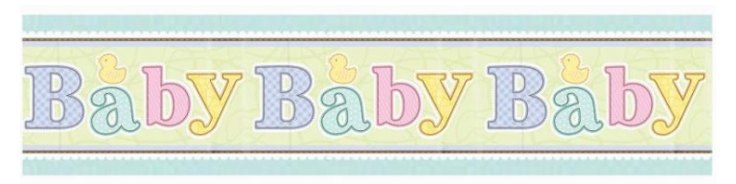
Website: www.babybabybaby.com.au
Email: info@babybabybaby.com.au
Ph: 0411 076 076
Fax: 03 9682 8419
Address: PO Box 1151
South Melbourne. 3207 Vic

Bartercard Order form
Please complete all sections and fax or email to us for processing

QTY | Item Number | Color | Size | Sub Total | Total
Shipping | $20.00
Gift Wrapping $4.95 per item | $
Other | $
Total | $
Gift Wrapping | Color Preference
Item #
Item #
Item #
- Gift Voucher : To _________________________ From: __________________________________

- Gift Voucher: To _________________________ From: __________________________________

Bartercard Details: | Shipping Details
Name: | Name:
Number: _ _ _ _ / _ _ _ _ / _ _ _ _ / _ _ _ _ | Address:
Exp:
 | Postcode: State:
Email: | Ph:

COMMENTS:____________________________________________________________________________________________________________________________________________________________________________________________________________________________

